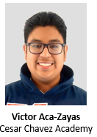  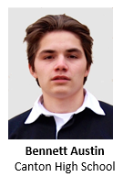  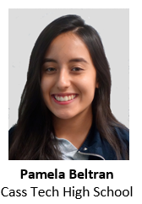  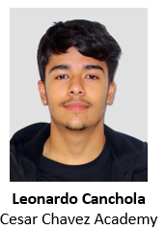  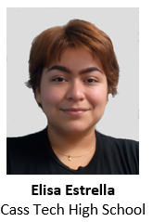  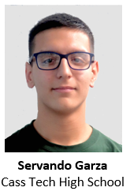  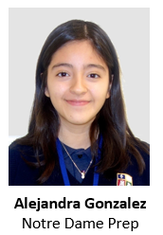  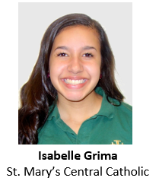  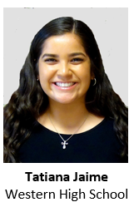  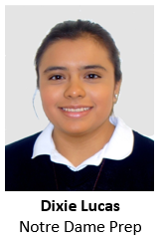  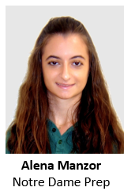  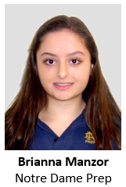  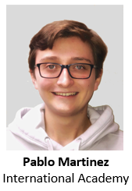  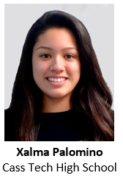  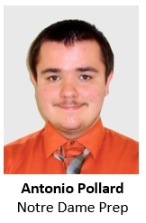  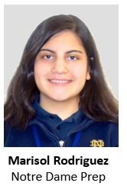  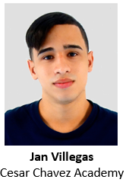  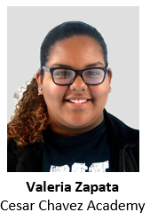 | Victor Aca-Zayas, an accomplished high school senior at Cesar Chavez Academy, holds a 3.86 GPA, participates as a member of his school’s robotics team and interned at Wayne State University as part of their Upward Bound program last summer.  “These organizations I joined gave me experiences I wouldn’t get anywhere else” wrote Victor in one of the essays on his scholarship application.  In addition, Victor is ranked 3rd of the 161 students in his class while being enrolled in multiple honors courses.  “Victor is an outstanding academic talent who pairs his skills with a superior work ethic,” Victor’s teacher wrote of him in his scholarship recommendation.  “[he] is among the most motivated students I have worked with in my 25 years of teaching.”  After graduation, Victor plans on attending the Wayne State University college of engineering to study to become an electronics engineer.  “Bennett is one of the most motivated students I have taught in my 30 years of teaching” says Canton High School student Bennett Austin’s math teacher. “He is always willing to sacrifice his time to help others”.  Bennett has a 4.0 GPA at Canton High School ranking number one in his class. Next fall he wants to attend Stanford University to study Physics. Bennett was inspired to focus on Physics from a visit to SpaceX with his grandfather. There he became fascinated with the idea of advancing space travel and set a goal to work at the company after college.  “My grandfather did me a huge favor taking me to SpaceX” he states in his essay role models. “While admiring the rockets being engineered and the designs being put in place, I realized that SpaceX is where I want to be.”  Recognizing the lack of Hispanics involved in STEM careers also motivates Bennett to be a role model and follow in the footsteps of his grandfather, an engineer.  Volunteering as a science instructor for STEM Library and STEM Elementary Days, tutoring at local libraries, packing food for Open Door Ministry and helping coach soccer are all ways in which Bennett gives back to his community.  With a 4.4 GPA Pamela Beltran-Mayen is ranked number 1 of 578 students in her class at Cass Tech High School. She is enrolled in the strenuous International Baccalaureate program with the goal to attend Harvard University next fall.  Pamela is very active in various community service efforts that have shaped her desire to study law and politics in college.  “In the future I hope to reform immigration policy to be more just” she says.  She is the president of the National Honors Society, works with the Congress of Communities, helped co-found Detroit Area Youth Uniting Michigan and CT Activists and is a core team member of 482 Forward.  Her math teacher is also her recommender rating her a “seek out” candidate with extraordinary capabilities. He describes her as a natural leader with a strong work ethic.  “Pamela sets long-term and short-term goals for college and her future career and she maps out steps toward them” he says.  “Leonardo knows what he wants and what it will take to get there. He understands that there will be things that get in the way, but knows he will overcome them.” Wrote one of Leonardo’s teacher’s in her student recommendation letter. “[he] has a complete concept of who he is.”  Leonardo Canchola, a high school senior at Cesar Chavez Academy, came to the United States with his family when he was just two years old. As a student, Leonardo is enrolled in multiple advanced courses and, in addition to his studies, works part time and volunteers whenever he can.  “Although I may be the one giving my time to help others, by sharing their laughter, their tears, and their stories with me, other people constantly inspire me to have faith that humans are good,” Leonardo wrote in one of his scholarship application essays.  Leonardo will be the first of his family to have the opportunity to continue his education after high school graduation.  “Both my mom and dad came to the U.S. to give my brother and I a better future,” Leonardo wrote.  After graduation, Leonardo would like to attend Michigan State University in East Lansing. While enrolled, Leonardo would like to major in engineering, with the long-term goal of becoming an Electrical Engineer.  Enrolling in the International Baccalaureate program at Cass Tech High School Elisa Estrella chose one of the most difficult programs available to challenge herself.  Elisa’s parents struggled to get money to buy books and uniforms in their native Mexico and immigrated to the United States to find a better future for their children. Her parents took her to the local public library to check out books and encouraged her to work ahead of her normal classwork.  Elisa’s extensive community service includes working with and being president of her local chapter of Build On, being Board Chair of the Congress of Communities, an organizer for 482 Forward, an education officer of the Latino Culture Club and co-president of the art club. Working with the Congress of Communities Youth Council she helped organize and implement a six-week program that prepared Latinx youth for higher education. The result instilled a sense of pride in Elisa when she saw the students excited about taking the next step and attending college.  In her essay on community service she states, “Through these services and programs I have found passion for helping my community, my Detroit”. At the same time she carries a 4.23 GPA at Cass Tech ranking in the top 5% of her class. Her goal is to attend Columbia University next fall and study Architecture.  Servando Garza points to his participation in Robotics as the key to developing his goal to enter the engineering field. Being a team captain exposed him to mechanical, electrical and computer engineering and sparked a desire to enter the STEM field.  Although his parents never competed high school they encouraged him to work hard at his studies and attend college.  Looking back at his success in school he states “I have accomplished things that I never expected I could” he says.  With a 4.04 GPA in the International Baccalaureate program at Cass Technical High School Servando would like to attend MIT next year.  His community service resume includes working as an educational liaison for the National Honors Society, a student aide for the counseling department and sitting on the executive board of the video game club. In addition, he has volunteered to work in the Del Ray community in Southwest Detroit to address concerns created by plans for a new international bridge.  His recommender rates him as an extraordinary candidate for this scholarship citing his leadership skills, strong familiar support and ability to succeed under pressure. Being the first in his family to attend college will allow Servando to fulfill his parents long standing goal for a better life for their children.  Alejandra Gonzalez attends Notre Dame Preparatory School where she currently maintains a GPA of 4.37 and has received the highest honors each year since she entered high school. She is currently an IB diploma candidate.  Last summer, Alejandra participated in a summer program on cognitive science at Cornell University.  In addition to her academic accomplishments, Alejandra created what is known at her high school as the Polyglot Club, which is essentially a forum for students to obtain independent language acquisition.  “I am amazed to witness her conduct simple vocab activities for her peers who are teaching themselves various second languages and am even more impressed at her peer’s gratitude for having a support group,” wrote one of her teachers in her student recommendation. “Alejandra is a talented, amazing young adult.”  In her spare time, Alejandra has volunteered at the Baldwin Center. As part of the Christians in Action peer ministry group at NDPS, Alejandra led the “Awareness Chats” aimed at helping people understand the struggles of those around the world and how they can help.  “Helping out with my school community has been one of the most rewarding experiences and helped show me that it doesn’t take too much to make a huge difference,” Alejandra wrote in one of her scholarship application essays.  After graduation, Alejandra plans to attend Cornell University where she will major in Human Development.  Isabelle Grima feels as though she grew up volunteering.  “whether it was a school or church event, my parents were always a part of it,” she wrote in an essay as part of her scholarship application.  Isabelle has volunteered her time at the Downriver Youth Performing Arts Center, with Downriver for Veterans, and at a soup kitchen her father ran at St. Mary’s Church, among others.  At the beginning of her Junior year of high school, Isabelle applied to go on a service trip to Harlan, Kentucky to help repair and build houses.  “It was eye-opening and gave me perspective in my life… I developed and immense amount of gratitude for my family and for those I experienced the volunteer trip with,” Isabelle wrote in one of her scholarship application essay submissions.  In addition to her dedication to helping others, Isabelle has excelled in her studies at St. Mary Catholic Central High School, enrolling in multiple honors classes.  “Isabelle is very deserving of this scholarship,” Isabelle’s college counselor wrote in her student recommendation, “she puts 110% into everything she does. This scholarship will allow her to follow her dreams.”  “My great-grandparents migrated from Mexico to make a better life for my grandparents and parents,” wrote Tatiana Jaime in a scholarship application essay submission. “Although I am third generation, my sister and I are the first generation to get the opportunity to attend college, with the help of my parents and grandmother.”  A senior at Western High School, Tatiana maintains a GPA of 3.9 and ranks 9th in her class of 522 students. In addition, she has been a part of the National Honor Society for bother her Junior and Senior year of high school.  “Tatiana is an outstanding individual with strong character,” one of Tatiana’s teachers wrote in his student recommendation. “[she] possesses the quality necessary to excel in college and her future career…Her integrity, work ethic, and personal convictions are of the highest caliber.”  In addition to excelling in her studies, Tatiana volunteers her time coaching younger girls through the Clark Park Coalition.  “Tatiana has exhibited superior mentoring skills and she is an excellent role model to the younger girls who idolize her.”  After graduation, Tatiana plans to study nursing at Oakland University and to eventually have a career as an ER Nurse.  Dixie Lucas credits her Hispanic heritage with driving her to work hard and achieve her personal and academic goals. She will be the first in her family to attend secondary education and hopes to attend DePaul University working toward a major in Childhood Development. She describes her heritage as “enriching” her life and instilling in her a desire to become a role model for others to follow.  Growing up Dixie was a regular at the Pontiac Public Library. Learning to read and understand English through the books she checked out weekly helped her to be successful in school. She carries a 3.56 GPA at Notre Dame Prep with numerous AP courses and is described as a candidate to “seek out” in her application package. Dixie now gives back to the Pontiac Public Library by volunteering there. Since her freshman year she spends two hours a week creating arts and crafts for the children’s events hosted at the facility.  “The work I do for the library is to make the children see it as a place for fun so that in the future they also pick up a book to further their education”. In addition, she volunteers for the Notre Dame ambassador program, peer leader group, school newspaper club and is a member of the National Honors Society.  With a 4.37 GPA in the International Baccalaureate program at Notre Dame Prep Alena Manzor would like to major in business at the University of Michigan next fall. “Through pursuing a career in business, I hope to become part of the business world that initiates positive change in both local communities and across the globe” she says. She points to her Cuban heritage and her grandfather as major influences in her life. Her grandfather always stressed “the importance of education and how it is a possession that can never be taken away from you”. As a result, she says “I developed an understanding of the power of education, and the power I could attain with education to discover what inspires me”. Her community service resume includes volunteer hours with Optimist Club, Campus Ministry, Waltonwood Senior Living and Safety Town. Inspired by her experience with a childhood friend who suffered from cancer she developed a project to donate toy care packages for Children’s Hospital of Michigan wrapping and delivering the packages herself. “I learned the power simple acts of kindness can have on people’s lives” she says about this effort. Her recommender describes her as “an engaged citizen, dedicated to making her school and community a better place” and rates her extraordinary in every category.  Brianna Manzor points to her Cuban heritage as a major influence in her life. Her Grandparents fled Cuba and communism to establish a new life for their family in America. “My Hispanic household has taught me not only the importance of school but also the importance of family” she says. She has “a passion for art and design” and has received several Scholastic Art Awards. Her goal is to pursue a career in Architecture and Design at the University of Michigan. “I am committed to bringing my cultural influences to the products and buildings I will design” she says, adding “it is my ambition to become active in serving underprivileged neighborhoods”. She sums up her thoughts on her heritage saying “My Hispanic upbringing has taught me that family, relationships, passions, commitment to others and hard work is what brings real meaning to life”. Brianna volunteers for the campus ministry, Optimist Club and Waltonwood Senior Living. Working with the seniors at Waltonwood connects her with her childhood days listening to stories of Cuba from her grandfather. “Visiting the elderly at the senior citizen homes is very enjoyable for me because I am aware of how much wisdom they have to share with me. Brianna carries a 4.11 GPA in the International Baccalaureate Program at Notre Dame Prep and is described by her art teacher as a “natural leader’ that is looked up to by peers and staff alike.  “I am determined, I am ambitious, I am optimistic,” Pablo Martinez wrote in one of his scholarship application essays. “I am all of these things through the teachings of my parents and my upbringing in these virtues and qualities surrounding my everyday life.”  Pablo Martinez is a high school senior at International Academy where he holds a weighted GPA of 3.92. In addition to his academic success, Pablo has participated as a leader in the Spanish Honor Society, volunteers at Habitat for Humanity, is a member of MAPS (Make a Person Smile), and serves as an elected official for his schools student government.  “He has a rare gift to get alone well with everyone,” one of Pablo’s teachers wrote in her student recommendation, “he genuinely loves people and cares about helping everyone do their best. For four years, Pablo has unanimously been elected as class representative.”  In addition, Pablo is enrolled in multiple honors courses and holds a part time job.  After graduation Pablo plans to attend the University of Michigan where he will study Psychology. Through his continued studies, Pablo hopes to have a career as an Industrial Organizational Psychologist and focus on the improvement of the work environment.  Xalma Palomino was inspired to become involved in civic engagement and community service through the Latino Youth Council of the Congress of Communities. The Council helps students whose families have little or no experience with higher education by providing resources and support, so they can understand the college process. Seeing the participants awaken to the possibility of attending an institute of higher learning motivated her to do more. Joining the National Honors Society, she now tutors freshmen in math and works in a food distribution center, work that she describes as “truly humbling”. With a 4.2 GPA in the International Baccalaureate program at Cass Tech High School Xalma wants to attend the University of Michigan next fall enrolling in the Medical program and Latino Studies. Rating her as a “seek out” candidate for the RGMF scholarship her recommender describes Xalma as “organized and diligent with a propensity for leadership”. In her essay on her influences Xalma cites her parents as key to her success. Her father who “always motivated” her to excel was deported when she was in fifth grade leaving her mother to raise her and her sister. That experience further drove her desire to succeed in school and attend college. In the words of her mother “The best inheritance I can leave you is an education”. Xalma wants to make the most of that inheritance.  Antonio Pollard, with a transcript decorated by countless honors courses, has maintained a 4.0 GPA during his 4 years at Cesar Chavez Academy High School and is ranked first in his class of 161 students.  “Antonio has challenged himself continuously in high school with his class choices and level of dedication,” wrote one of Antonio’s teachers in her student recommendation.  In addition to his studies, Antonio has spent time interning at DTE Energy and Giffels Webster, as the strategy lead for his school’s robotics team, and as a youth mentor for the Detroit Hispanic Development Corporation.  “I got to experience the unique joy of mentoring youth in the community…which imparted onto me both a sense of purpose and a sense of responsibility,” Antonio wrote in a scholarship application essay. “these experiences where I was given the opportunity to give back to the community didn’t really feel like giving, because it felt like I was getting just as much, if not more from the experience as everyone else.”  After graduation, Antonio plans to attend the Massachusetts Institute of Technology where he will major in Mechanical Engineering in order to one day obtain a career as a robotics engineer.  Marisol Rodriguez attends Notre Dame Prep and carries a 4.05 GPA with numerous honors and AP courses. As a tutor at Walton Charter Academy she works with third grade students to help them improve their reading and comprehension with the goal that they will become life long readers.  “I always find myself transported to a whole new world when I read, and I want the newer generation to experience this feeling” she says. She specifically works students who struggle with English and says, “I want to give this gift (the love of reading) to others who might not even own books in their homes”.  Marisol would like to attend the University of Michigan next year and major in political science. She credits her family for instilling an unending passion for learning in her, explaining “my parents have always encouraged my creativity and curiosity by obtaining resources like school books and websites that are fun for me to practice with”. Neither of her parents attended college but they “fueled” Marisol’s “imaginative spirit” and find great joy in her retelling of stories she reads. Her English teacher describes her as a “model” of the school’s mission to create “upright citizens” pointing to her work to further children’s literacy.  In recommending Marisol as a top candidate for the scholarship her teacher says, “her sense of social justice is clear” and she “has clear goals and reasoning for becoming involved in the political world eventually”.  Jan Villegas is still learning to speak English while he completes high school at Cesar Chavez Academy. Even with this major hurtle, Jan has earned a 3.33 GPA.  “I am struggling to get ahead and not give up,” Jan wrote in a scholarship application essay, “it is difficult but I don’t intend on giving up because it is only an obstacle to pass and overcome as I was taught.”  Prior to moving to the United States, Jan volunteered as a part of CERT to help the victims of hurricane Maria after it moved through Puerto Rico.  “I was always willing to help anyone who needed help after the hurricane,” wrote Jan.  “[Jan] has shown great willingness to attempt things that are challenging—I have seen this in his English learning process,” wrote one of Jan’s teachers in her student recommendation. “[he is] one of the few students who consistently stays after school for assistance on assignments.”  After graduating high school, Jan would like to attend the MIAT College of Technology and would eventually like to have a job in aviation maintenance.  Valeria Zapata, a high school senior at Cesar Chavez Academy, is one of the first of her family to attend school in the United States. Her parents new to the United States after leaving Honduras, Valeria’s father was deported when she was in fourth grade.  “Every time I talk to my dad it motivates me to do my best in everything I do, no matter what,” wrote Valeria Zapata in one of her scholarship application essays. “There have been many ups and downs, but whatever the case was, I have always tried my best to turn my stress into strength,”  Balancing school and home life, where she would look after her little sister if her mother worked a second shift, Valeria has maintained a near 3.0 GPA.  “I am always impressed by her level of intrinsic motivation to learn the material and perform well in class” wrote one of Valeria’s teachers in her student recommendation.  After graduation, Valeria plans to attend Wayne State University. She would like to major in legal studies and eventually hold a career as an attorney.

Congratulations to all our Scholarship Recipients

